[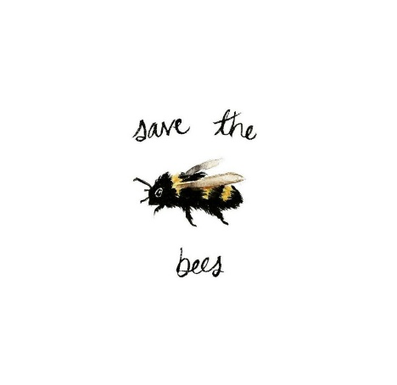](https://www.google.co.uk/url?sa=i&rct=j&q=&esrc=s&source=images&cd=&cad=rja&uact=8&ved=2ahUKEwiNhaOe44HgAhU-TxUIHY4sCDMQjRx6BAgBEAU&url=https://www.pinterest.com/pin/119626933839950434/&psig=AOvVaw1eyMHRTLUC1HqO5dyUj53l&ust=1548259601283276)[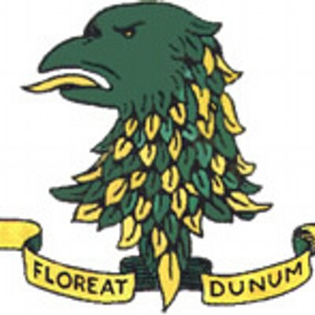](https://www.google.co.uk/url?sa=i&rct=j&q=&esrc=s&source=images&cd=&cad=rja&uact=8&ved=2ahUKEwiIucyT4oHgAhVmSxUIHdB2CScQjRx6BAgBEAU&url=https://twitter.com/downhighschool&psig=AOvVaw0x7sbn8ftQf84LUfKONhTc&ust=1548259473430570) **Be Fair to Bees and give Youth a Voice.**

DHS Students need your help. They are the first group of young people in The UK that have succeeded in getting an E petition uploaded onto the UK Parliament petition website. They want to raise awareness of the importance and plight of pollinators in the UK. As the next generation of environmental caretakers, they feel strongly about the need to safeguard important Agri-Incentive and conservation initiatives which, as their own project work shows, positively help to increase the number of important pollinator species.

Over the past 5 years, pupils from DHS have carried out important project work supported by bursaries from Sentinus and the Nuffield Research group and mentored by the RSPB.

Last year pupils Paul McKenna and Chris McKenna-Ell, presented their findings to the UK RSPB annual members meeting at Nottingham University, and this

summer, A2 student Annie Magowan, collected clear evidence of the increase in key pollinator species on local farms which employ Agri-Incentive schemes.

She also highlighted the benefit of certain pollinator plants during extreme periods of hot weather.

Annie’s findings and those of the students before her, serve to highlight the need for urgent action re. the safeguarding of such conservation schemes. The pupils fear that environmental issues, that will affect all of us, will be side-stepped. Due to the absence of local government, they have decided to go directly to the UK Parliament petition site.

They need at least 10,000 signatures; BUT 100,000 will assure that their issue is debated in Parliament.

They are full of youthful enthusiasm and hope, which is to be commended. So please sign the petition and spread the word.

Anyone can sign as long as they are UK citizens and have a UK postcode.

If you click on the petition you will be sent a confirmation email to verify that you are human!

If you have multiple emails, please sign multiple times.

**But remember - Please Verify your email.**

Thank you.

Scan QR code to bring up url directly or follow the link below.

<https://petition.parliament.uk/petitions/235644>

Or, Google UK parliament petitions and type in Bee Fair To Bees.

[](https://www.google.co.uk/imgres?imgurl=https://www.popcornfestival.com/media/2016/01/thank-you.jpg&imgrefurl=https://www.popcornfestival.com/news/thank-you-for-a-great-festival/&docid=cnTROKZbJVchQM&tbnid=kZuqS2COt9HtjM:&vet=10ahUKEwi07LL394jgAhWUShUIHSWxCk4QMwilASgxMDE..i&w=1920&h=1080&hl=en&safe=active&bih=586&biw=890&q=Thank%20you&ved=0ahUKEwi07LL394jgAhWUShUIHSWxCk4QMwilASgxMDE&iact=mrc&uact=8)