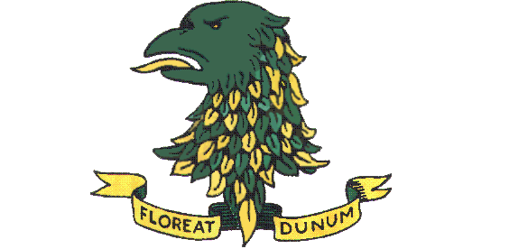
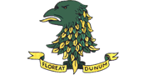
DOWN HIGH SCHOOL
“Nothing Achieved Without Effort”
6th Form Intake Day
Thursday 12 August from 9.00am

We look forward to welcoming many new students into our enlarged 6th Form. Down High offers a large menu of post-16 courses, including traditional A-Levels and Applied A-Levels plus BTEC or Level 3 courses in ICT, Engineering, Sport and Tourism. Excellent pastoral support and careers guidance are central to all that we do in Down High School, and our extensive range of extra-curricular and other enrichment activities make 6th Form a wholly rewarding experience. So many pupils who joined our enlarged 6th Form have left Down High with the qualifications, knowledge and skills needed for further education and the world of work, with many achieving A*, A and Distinction grades.
Please come to see us on Thursday 12 August, bringing your statement of GCSE grades with you. We would like to meet you to discuss the pathways that can allow you to remain in a school setting and help you reach your potential.
On arrival, please enter the school by the main entrance. For your own safety, and that of others, please wear a face covering inside the school and follow the hygiene and social distancing measures that we will have in place.

www.downhighschool.org.uk/

